**“WEBSITE FOR HOSTEL MANAGEMENT SYSTEM”**

**Avadhut S.Chavan 1, Bhushan R.Mote 2 , Sahil S.Sadekar3 , Pavan D.Wagh 4**

**1,2,3,4 Sveri’s College of Engineering (Polytechnic), Pandharpur, Maharashtra, India**

[aschavan@cod.sveri.ac.in](mailto:aschavan@cod.sveri.ac.in) , [brmote@cod.sveri.ac.in](mailto:brmote@cod.sveri.ac.in) , [sssadekar@cod.sveri.ac.in](mailto:sssadekar@cod.sveri.ac.in) , [pdwagh@cod.sveri.ac.in](mailto:pdwagh@cod.sveri.ac.in)

**Abstract** : The Hostel Management System is a software application designed to simplify and streamline the management of a hostel or a similar accommodation facility. This system automates the daily operations of the hostel, including room allocation, check-in and check-out, billing, inventory management, and other related activities. The system helps the hostel administrators to keep track of the available rooms, their occupancy status, and their maintenance requirements. It also allows guests to make online reservations and payments, view room availability and other amenities, and communicate with the hostel staff. Overall, the Hostel Management System is an efficient and effective solution for managing hostel operations, improving customer service, and increasing profitability.

***Keywords*:** Management, Hostel, System, Operations

**1 Introduction :**

The Hostel Management System project is a software application designed to automate and streamline the management of hostel operations. Hostels provide affordable accommodations for students, travelers, and other individuals, and managing these facilities can be a complex and challenging task. The Hostel Management System project aims to simplify and automate many of the tasks involved in managing a hostel, including room allocation, check-in and check-out, billing, inventory management, and more.

This system provides an efficient and effective solution for hostel administrators to keep track of room occupancy, maintenance requirements, and other essential information. It also offers guests a user-friendly platform to make online reservations, view room availability, and communicate with hostel staff.

The Hostel Management System project aims to improve the overall customer experience by providing a more streamlined and convenient booking process, reducing wait times, and providing access to essential information. Additionally, the system can increase profitability for the hostel by improving occupancy rates, reducing operating costs, and providing real-time insights into key metrics.

Overall, the Hostel Management System project is an essential tool for hostel owners and administrators looking to improve their operations, provide better customer service, and increase profitability.

# **2 Related Work**

In conclusion, the Hostel Management System is an important tool for managing hostel operations efficiently and effectively. The system includes a range of features such as room management, reservation management, billing, and reporting, which helps hostel owners and administrators manage their inventory, reservations, billing, and guest communications.

Through a literature survey, it was found that several research works have been done in the area of hostel management systems. The proposed systems offer features that make hostel management more efficient, customizable, and scalable. These systems can be accessed from anywhere and at any time, making it easier for hostel staff to manage their operations.

The Hostel Management System project software is designed to provide a simple, user-friendly interface that allows hostel staff and guests to easily access the features they need. The software is also highly customizable, allowing hostel owners to tailor it to their specific needs and preferences.

Overall, the Hostel Management System project software is an efficient and effective solution for managing hostel operations, improving customer service, and increasing profitability. By implementing the Hostel Management System, hostel owners and administrators can streamline their operations, reduce costs, and provide better services to their guests.

model information of hostel management website

A hostel management website typically consists of several models or components that work together to manage hostel operations efficiently. Here are some of the key models typically used in hostel management websites:

1. User Model: The User model manages information about the users of the hostel management website, including hostel owners, administrators, staff, and guests. This model typically includes information such as user IDs, names, contact information, and user roles.
2. Room Model: The Room model manages information about the rooms available in the hostel, including room types, room numbers, room features, and room availability. This model is used to manage room reservations and to track occupancy rates.
3. Reservation Model: The Reservation model manages information about the reservations made by guests, including check-in and check-out dates, room types, room numbers, and guest information. This model is used to manage the availability of rooms, to generate invoices and receipts, and to track payment status.
4. Billing Model: The Billing model manages information about billing and payment transactions, including invoices, receipts, payment methods, and payment status. This model is used to generate bills and invoices for guests, to track payment status, and to generate financial reports.
5. Housekeeping Model: The Housekeeping model manages information about housekeeping and maintenance tasks, including cleaning schedules, maintenance requests, and housekeeping staff assignments. This model is used to track room cleaning and maintenance status, and to manage housekeeping and maintenance staff schedules.
6. Reporting Model: The Reporting model manages information about hostel operations and generates reports on occupancy rates, revenue, expenses, and other key performance indicators. This model is used to provide insight into hostel performance, to identify areas for improvement, and to help hostel owners and administrators make data-driven decisions.

Overall, these models work together to provide a comprehensive and integrated solution for managing hostel operations. By using these models, hostel owners and administrators can streamline their operations, improve customer service, and increase profitability.

# **3 Literature survey:**

# **3.1 Problem Definition**- The current system of managing hostels is manual and time-consuming. Hostel managers face difficulties in managing room allocations, handling room complaints, tracking inventory and maintenance, and maintaining attendance records of hostel residents.

# **3.2 Existing System**- The existing hostel management system lacks efficiency and effectiveness in managing student accommodations, meal plans, and other facilities. The manual process of managing hostel facilities is time-consuming and prone to errors. The current system also lacks real-time data analysis and reporting, making it difficult for administrators to make data-driven decisions. This has resulted in a lack of transparency and accountability, leading to dissatisfaction among students and staff. Therefore, there is a need for an automated and integrated hostel management system that can efficiently manage student accommodations, meal plans, and other facilities, provide real-time data analysis and reporting, and enhance transparency and accountability. The new system should be user-friendly, easy to access, and compatible with existing systems.

# **3.3 Proposed System** -An advanced hostel management website is a comprehensive and integrated system that provides a complete solution for managing student accommodations, meal plans, and other hostel facilities. It is an online platform that can be accessed by students, hostel administrators, and other stakeholders to manage and monitor various hostel-related activities.

# An advanced hostel management website includes modules for student registration, room allocation, mess management, inventory management, attendance tracking, billing and payment, and reporting. The system uses advanced technologies such as cloud computing, machine learning, and data analytics to provide real-time data analysis and reporting, enhance efficiency and effectiveness, and improve the overall hostel experience for students and staff.

# The website is user-friendly, easy to access, and compatible with different devices and platforms. It is also secure and reliable, ensuring the privacy and confidentiality of student data and other sensitive information. The advanced hostel management website is designed to automate and streamline hostel management processes, reducing the workload of administrators and enhancing transparency and accountability.

# **4 System Architecture**

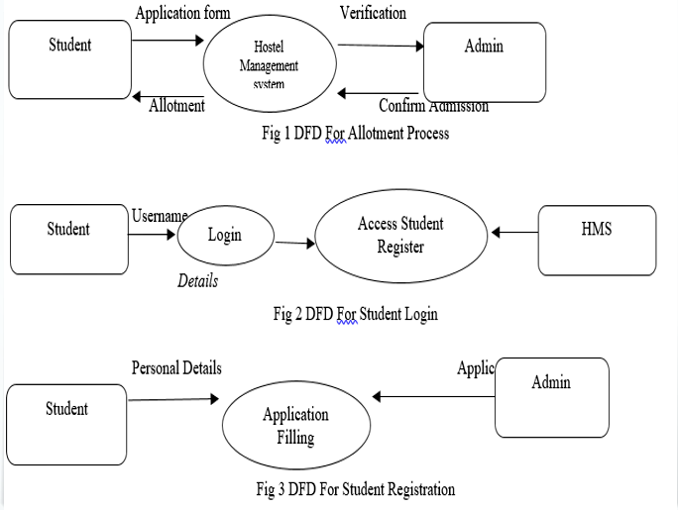

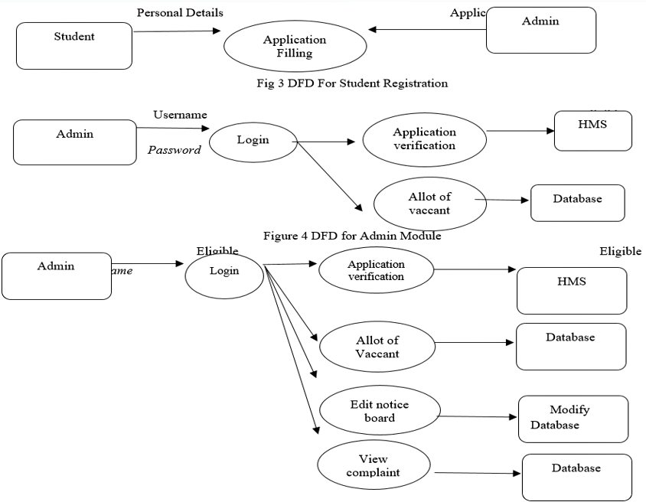

# Overall, this DFD provides a high-level overview of the data flow and processing in a hostel management system. It can be used as a starting point for more detailed analysis and design of the system.

# **5 Experimental Results and performance**

In order to test the above model by using hostel management system and the rules defined in the present study the small data from one of the engineering college have been used. From the input data the output variable student’s reviews and performance is determined by Relative operations and also by using the hostel management in the study.

1. Efficiency: The system should be efficient in managing various tasks related to hostel management, such as room allocation, booking management, and check-in and check-out processes. A fast and reliable system will improve the overall efficiency of the hostel operations.
2. Accuracy: The system should be accurate in recording and retrieving information related to room occupancy, guest information, billing, and other important data. A high degree of accuracy will prevent errors and mismanagement of resources.
3. User-friendliness: The system should be user-friendly and easy to navigate for both staff and guests. A user-friendly system will reduce training time and improve the user experience for both staff and guests.
4. Security: The system should be secure and protect sensitive data such as guest personal information, financial transactions, and confidential business information. A secure system will help to maintain trust between the hostel and its guests.
5. Scalability: The system should be scalable to handle growing hostel operations and expanding business needs. A scalable system will ensure that the hostel can handle more guests and manage more rooms without affecting the quality of service.

**6 Future Scope**

# Integration with other systems: The hostel management system can be integrated with other systems, such as the student information system or the financial system, to provide a more comprehensive view of student-related activities.

# Mobile application: A mobile application can be developed for the hostel management system, enabling students and staff to access relevant information and services on their mobile devices.

# Artificial Intelligence (AI) and Machine Learning (ML): AI and ML technologies can be incorporated into the hostel management system to provide predictive analytics and personalized services to students.

# Smart features: The hostel management system can be equipped with smart features, such as smart locks and IoT-enabled devices, to enhance security and improve the overall hostel experience.

# Sustainability: The hostel management system can be designed to promote sustainability, such as energy-efficient lighting systems and waste management programs.

# By incorporating these features and technologies, the hostel management system can provide more comprehensive and personalized services to students, enhance the efficiency and effectiveness of hostel management, and improve the overall hostel experience.

# **7 Advantages of the system**

1. Efficient management: A hostel management system can automate and streamline various hostel-related activities, reducing workload, and enhancing efficiency and effectiveness.
2. Real-time data analysis and reporting: The system can provide real-time data analysis and reporting, enabling administrators to make data-driven decisions and identify areas for improvement.
3. Improved transparency and accountability: The system can enhance transparency and accountability by providing students and staff with access to relevant information and enabling administrators to track and monitor hostel-related activities.
4. Enhanced student experience: A hostel management system can improve the overall hostel experience for students by providing a user-friendly platform for submitting requests and feedback, managing accommodations, and accessing relevant information.
5. Cost-effective: A hostel management system can reduce the cost associated with managing hostels manually, such as staff salaries, administrative expenses, and paper-based processes.
6. Improved security: The system can enhance security by enabling administrators to monitor and track hostel activities and ensuring that only authorized personnel have access to sensitive information.

# **8.Implementation**

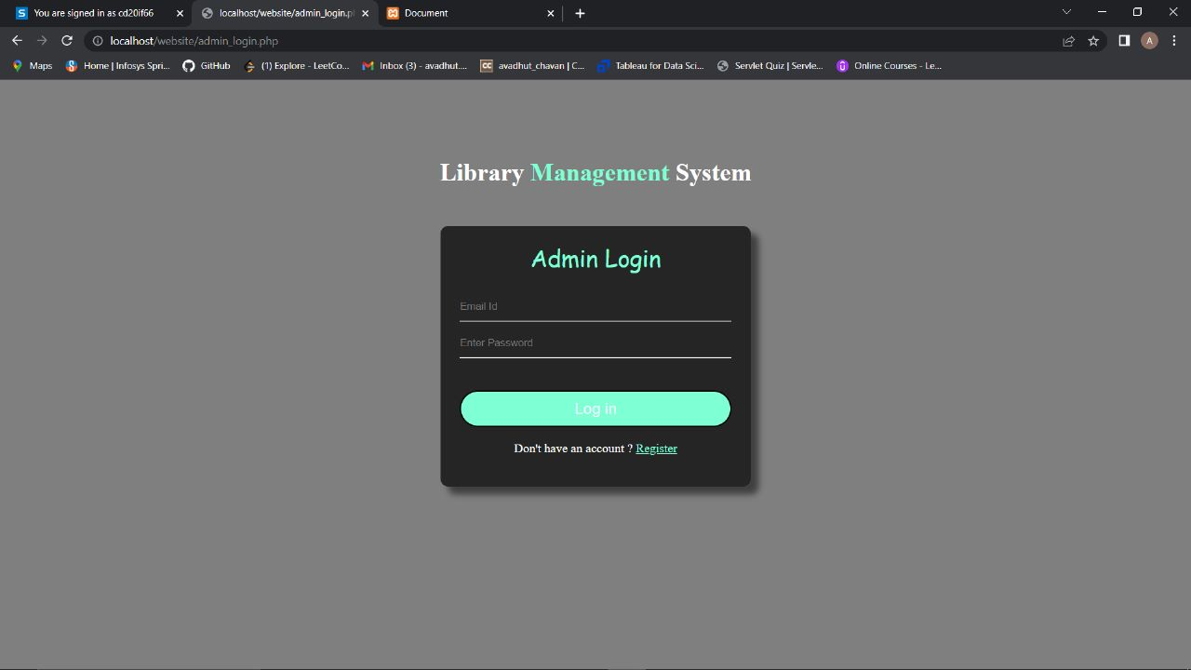

1. A hostel management website admin page typically provides access to the website's backend management system. This allows administrators to manage various aspects of the website, including user accounts, room bookings, payment processing, and website content.
2. The ability to manage room reservations, including booking confirmation, cancellations, and modifications.

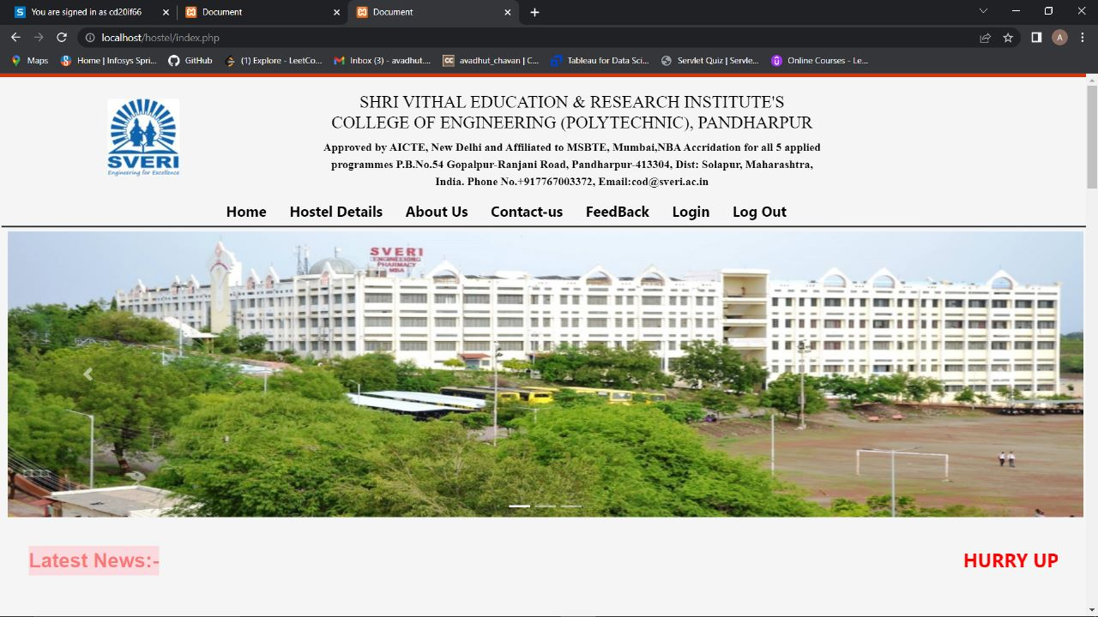

A hostel management website home page is the primary page of a website that visitors see when they land on the site. It is the first impression that potential guests will have of the hostel and is therefore critical in attracting and retaining visitors.

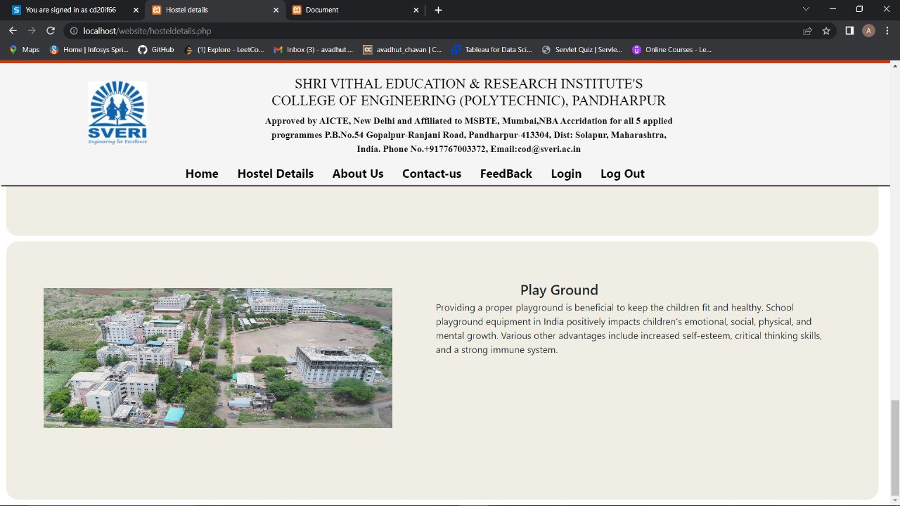

1. Location: A map and description of the hostel's location, including nearby attractions, transportation options, and points of interest.
2. Facilities: A list of the hostel's facilities, including common areas, play ground, laundry facilities, and other amenities that are available to guests.

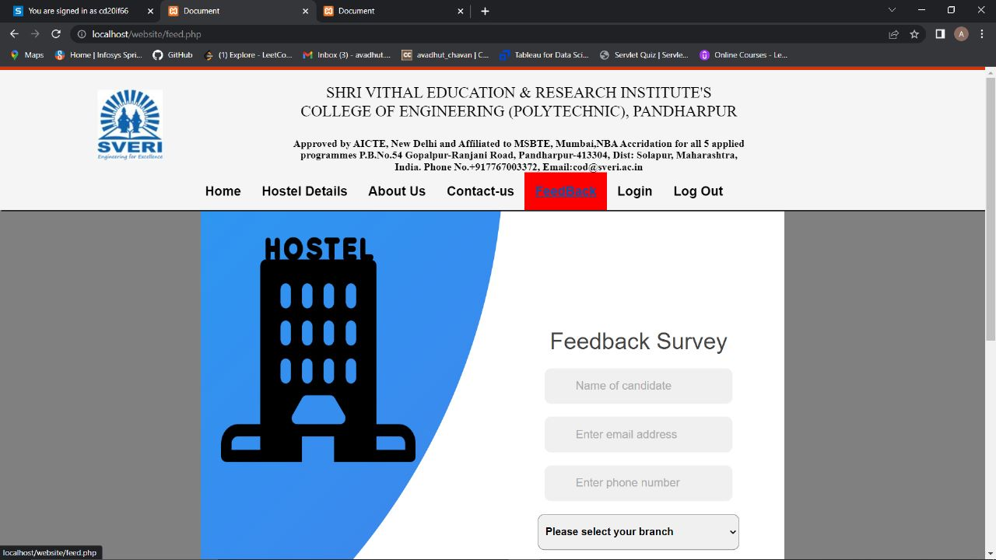

1. A hostel management website feedback page is designed to collect feedback and reviews from guests who have stayed at the hostel. This feedback can be used to improve the hostel's services, amenities, and overall guest experience.
2. Overall, a feedback page is an important component of a hostel management website, as it provides valuable insights into the guest experience and allows the hostel to make improvements and adjustments based on guest feedback. By providing a platform for guests to share their opinions, a feedback page can also help to build trust and loyalty with guests, and promote the hostel to a wider audience.

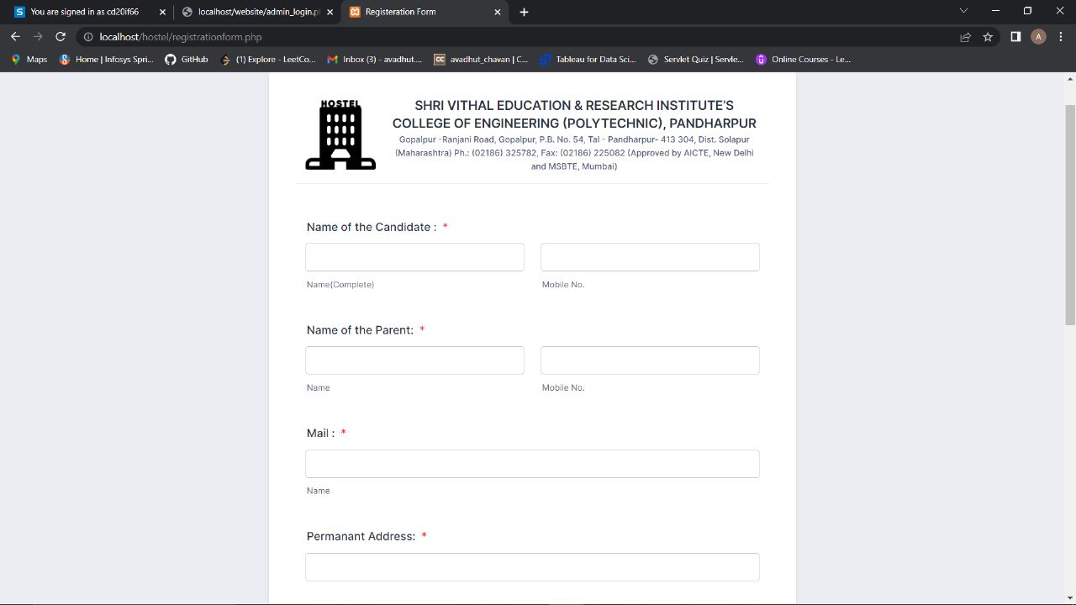

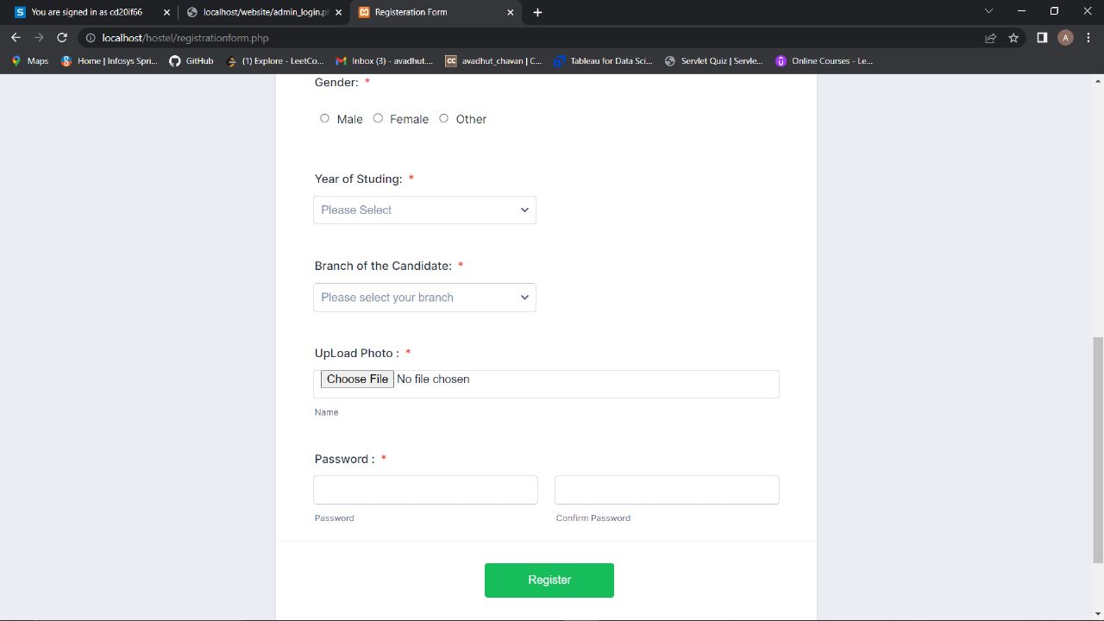

1. A hostel management website registration page is designed to allow users to create an account on the website. This account can be used to book rooms, view past bookings, and access other features and
2. Overall, a registration page is an important component of a hostel management website, as it allows users to create an account and access features and information that may not be available to non-registered users. By collecting user information, a registration page also helps the hostel to better understand its audience and tailor its services to meet their needs.
3. Some websites may require users to verify their email address or phone number before allowing them to create an account. This helps to ensure that the account is created by a real person and not a bot or automated program.

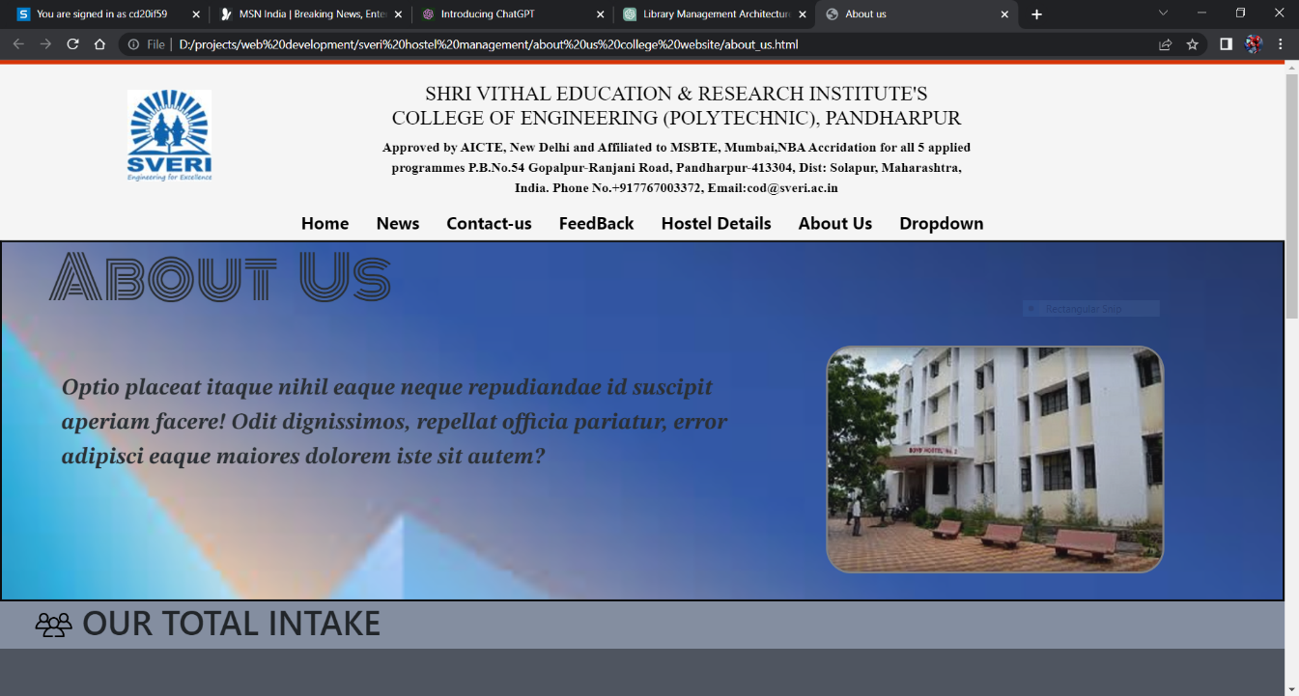

1. A hostel management website About Us page is a section of the website that provides information about the hostel and its management team. This page is designed to help potential guests learn more about the hostel, its values, and its mission, and to build trust and credibility with website visitors.
2. Overall, an About Us page is an important component of a hostel management website, as it provides valuable information about the hostel and its operations. By sharing information about the management team, facilities, and community involvement, a hostel can build trust and credibility with potential guests, and differentiate itself from other hostels in the market.

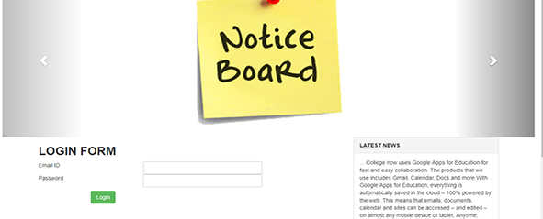

A hostel management website's noticeboard page is a section on the website that allows administrators, staff, and residents to share important information with one another. The noticeboard page can be accessed by logging in to the website, and it typically contains announcements, news, and updates that are relevant to the hostel community.

**9 Conclusion:**

In conclusion, the Hostel Management System is an important tool for managing hostel operations efficiently and effectively. The system includes a range of features such as room management, reservation management, billing, and reporting, which helps hostel owners and administrators manage their inventory, reservations, billing, and guest communications.

The Hostel Management System project software is designed to provide a simple, user-friendly interface that allows hostel staff and guests to easily access the features they need. The software is also highly customizable, allowing hostel owners to tailor it to their specific needs and preferences.

Overall, the Hostel Management System project software is an efficient and effective solution for managing hostel operations, improving customer service, and increasing profitability. By implementing the Hostel Management System, hostel owners and administrators can streamline their operations, reduce costs, and provide better services to their guests.

Top of Form

# **10 References**

[1] <https://projectworlds.in/free-projects/php-projects/hostel-management-system-project-in-php/>

[2] <https://www.academia.edu/37040228/HOSTEL_MANAGEMENT_SYSTEM_full_project_1_>

[3] [https://phpgurukul.com/hostel-management-system/](https://phpgurukul.com/hostel-management-system/%20)

[4] <https://github.com/topics/hostel-management-system>

[5]<https://www.bing.com/ck/a?!&&p=45fd15026670db0fJmltdHM9MTY3ODU3OTIwMCZpZ3VpZD0wZjg4ODAwMi02YzMzLTY1NDAtMzFhYy05MDkyNmQ5ZTY0NGUmaW5zaWQ9NTQwMA&ptn=3&hsh=3&fclid=0f888002-6c33-6540-31ac-90926d9e644e&psq=hostel+management+system+project+in+php&u=a1aHR0cHM6Ly93d3cuc3R1ZG9jdS5jb20vaW4vZG9jdW1lbnQvY2hhbmRpZ2FyaC11bml2ZXJzaXR5L2J0ZWNoLWNzZS9ob3N0ZWwtbWFuYWdlbWVudC1zeXN0ZW0tZmluYWwtcmVwb3J0LzM5NTkzNTQ4&ntb=1.>

[6]<https://www.bing.com/ck/a?!&&p=d3e57fc872a0877cJmltdHM9MTY3ODU3OTIwMCZpZ3VpZD0wZjg4ODAwMi02YzMzLTY1NDAtMzFhYy05MDkyNmQ5ZTY0NGUmaW5zaWQ9NTE4Mw&ptn=3&hsh=3&fclid=0f888002-6c33-6540-31ac-90926d9e644e&psq=notice+board+using+php&u=a1aHR0cHM6Ly93d3cuc291cmNlY29kZXN0ZXIuY29tL3BocC8xNDMxNy9vbmxpbmUtbm90aWNlLWJvYXJkLXN5c3RlbS5odG1s&ntb=1>

[7]<https://www.bing.com/ck/a?!&&p=c410a8ed80f93866JmltdHM9MTY3ODU3OTIwMCZpZ3VpZD0wZjg4ODAwMi02YzMzLTY1NDAtMzFhYy05MDkyNmQ5ZTY0NGUmaW5zaWQ9NTIzMg&ptn=3&hsh=3&fclid=0f888002-6c33-6540-31ac-90926d9e644e&psq=notice+board+using+php&u=a1aHR0cHM6Ly9jb2RlLXByb2plY3RzLm9yZy9vbmxpbmUtbm90aWNlLWJvYXJkLXVzaW5nLXBocC1zb3VyY2UtY29kZS8&ntb=1>